VA-001 — Use of Vulnerable Third-Party Component (esbuild)
Finding ID | VA-001
Severity | High
CVSS v3.1 Score | 8.1 (CVSS:3.1/AV:N/AC:H/PR:N/UI:N/S:U/C:H/I:H/A:H)
Assessment Type | SCA
Affected Asset / Component | Node.js Application Dependencies (esbuild)
CWE Reference | N/A
CVE Reference | N/A
Status | Open
Description
The application utilizes a vulnerable version of the esbuild package. Dependency analysis identified that the installed version falls within the affected range 0.17.0 – 0.28.0, which is subject to publicly disclosed security vulnerabilities.
According to the security advisories, affected versions of esbuild are vulnerable to:
- Missing binary integrity verification in the Deno module, potentially enabling remote code execution through manipulation of the NPM_CONFIG_REGISTRY setting.
- Arbitrary file read vulnerabilities when running the development server on Windows environments.
Evidence / Proof of Concept
N/A
Impact
Successful exploitation of these vulnerabilities could allow an attacker to:
- Execute arbitrary code under specific conditions.
- Read unauthorized files from the underlying system.
- Compromise application integrity and confidentiality.
- Leverage supply-chain attack vectors through dependency manipulation.
Recommendation
- Upgrade esbuild to the latest secure version recommended by the vendor.
- Review the dependency tree to identify any packages that indirectly depend on vulnerable versions of esbuild.
- Implement a software composition analysis (SCA) process within the CI/CD pipeline to continuously monitor third-party dependencies for known vulnerabilities.
- Regularly update project dependencies and apply vendor security patches.
Done:
Summary: I Updated the dependency chain by upgrading tsx and refreshing its transitive dependency esbuild from v0.28.0 to v0.28.1, thereby removing the vulnerable version identified in the security assessment. Then audit fix the Package vulnerablilities.

Check : 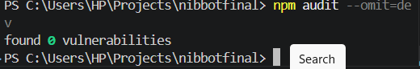

VA-002 — Server-Side Request Forgery (SSRF) Risk via Unrestricted Proxy Endpoint
Finding ID | VA-002
Severity | High
CVSS v3.1 Score | CVSS: 8.1 – HIGH
Assessment Type | SAST
Affected Asset / Component | src/app/api/proxy/route.ts
CWE Reference | CWE-918: Server-Side Request Forgery (SSRF)
CVE Reference | N/A
Status | Open
Description
The proxy endpoint accepts a user-supplied URL and forwards requests using server-side fetch() without validating or restricting the destination. The application only checks that the URL begins with http or https.
Evidence / Proof of Concept
const { url } = body;

if (!url.startsWith('http')) {
return error;
}

const response = await fetch(url, fetchOptions);

Impact
An attacker may abuse the proxy endpoint to make requests to arbitrary external or internal systems through the application server. This could allow access to internal services, exposure of sensitive information, network reconnaissance, or bypass of network access restrictions.
Recommendation
- Implement a strict allowlist of approved destination domains.
- Block requests to localhost, private IP ranges, and cloud metadata services.
- Validate and normalize URLs before processing.
- Restrict the proxy functionality to trusted destinations only.
- Monitor and log outbound requests for suspicious activity.
Done:
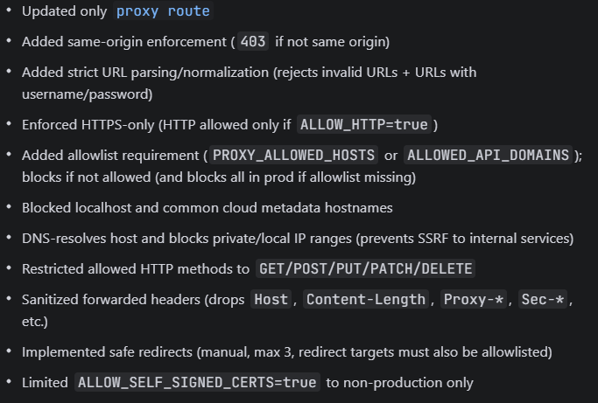
The SSRF vulnerability in the proxy endpoint has been mitigated by implementing strict request validation and outbound request controls. The endpoint now enforces same-origin request checks, performs full URL parsing and normalization using new URL(), and restricts communication to HTTPS only (with HTTP disabled by default). A strict allowlist mechanism has been introduced to ensure only approved domains can be accessed, while all other destinations are blocked by default in production.
Additionally, internal network protection has been implemented by blocking localhost, private IP ranges, and cloud metadata service addresses. DNS resolution is used to prevent DNS rebinding attacks by validating resolved IPs before sending requests. The proxy also enforces safe request handling by limiting allowed HTTP methods, sanitizing headers, and controlling redirect behavior with a maximum of 3 validated hops.
Overall, these controls eliminate arbitrary server-side request execution and significantly reduce SSRF exploitation risk.

VA-003 — Vulnerable form-data Dependency
Finding ID | VA-003
Severity | High
CVSS v3.1 Score | 7.5 (High)  (CVSS:3.1/AV:N/AC:H/PR:N/UI:N/S:U/C:H/I:H/A:H)
Assessment Type | SCA
Affected Asset / Component | form-data npm package
CWE Reference | CWE-93 – Improper Neutralization of CRLF Sequences
CVE Reference | N/A
Status | Open
Description
- The application contains a vulnerable version of the form-data library (4.0.0–4.0.5). The vulnerability allows CRLF injection through improperly sanitized multipart field names and filenames.
Evidence / Proof of Concept
form-data 4.0.0–4.0.5
Impact
- An attacker may manipulate multipart request construction, potentially leading to request tampering or unexpected application behavior.
Recommendation
- Upgrade form-data to version 4.0.6 or later.
Done:
I updated as audit fix or npm install form-data@latest
Check: 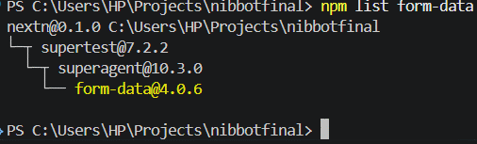

VA-004 — Vulnerable hono Dependency
Finding ID | VA-004
Severity | High
CVSS v3.1 Score | 8.1 (CVSS:3.1/AV:N/AC:H/PR:N/UI:N/S:U/C:H/I:H/A:H)
Assessment Type | SCA
Affected Asset / Component | hono npm package
CWE Reference | CWE-22 – Path Traversal
CVE Reference | N/A
Status | Open
Description
- The application contains a version of the hono framework (≤ 4.12.24) affected by multiple security vulnerabilities, including path traversal, improper CORS handling, request processing weaknesses, and AWS adapter-related issues.
Evidence / Proof of Concept
hono <= 4.12.24
Impact
- Depending on application usage, attackers may exploit affected functionality to bypass security controls, access unintended resources, or disrupt application availability.
Recommendation
- Upgrade hono to a version later than 4.12.24 and review the use of affected middleware and adapters.
Done:
Using audit fix or npm install hono@latest
Check: 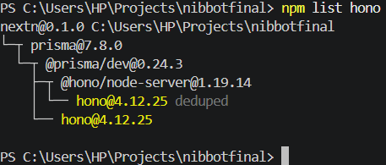
VA-005 — Vulnerable ws Dependency
Finding ID | VA-005
Severity | High
CVSS v3.1 Score | 7.5 (CVSS:3.1/AV:N/AC:H/PR:N/UI:N/S:U/C:H/I:H/A:H)
Assessment Type | SCA
Affected Asset / Component | ws npm package
CWE Reference | CWE-400 – Uncontrolled Resource Consumption
CVE Reference | N/A
Status | Open
Description
- The application contains a vulnerable version of the ws WebSocket library (8.0.0–8.20.1). The vulnerability may allow memory exhaustion through specially crafted fragmented WebSocket messages.
Evidence / Proof of Concept
ws 8.0.0 - 8.20.1
Impact
- An attacker may consume excessive server memory, potentially resulting in denial of service and reduced application availability.
Recommendation
- Upgrade ws to version 8.20.2 or later and implement appropriate WebSocket connection and message size limits.
Done
I updated its version using npm audit or npm install ws@latest
Check: 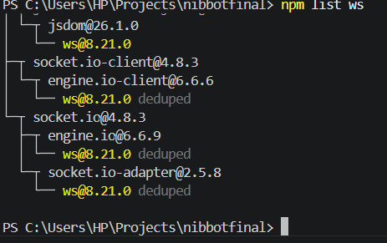
- Message Size Limit ( maxHttpBufferSize: 1e6 / 1MB)
- Per-IP Connection Limit (MAX_SOCKET_CONNS_PER_IP: 20)

VA-006 — Weak Password Policy Enforcement
Finding ID | VA-006
Severity | Medium
CVSS v3.1 Score | 5.3 (Medium) CVSS:3.1/AV:N/AC:L/PR:N/UI:N/S:U/C:L/I:L/A:N
Assessment Type | DAST
Affected Asset / Component | Authentication Module / Password Policy
CWE Reference | CWE-521 – Weak Password Requirements
CVE Reference | N/A
Status | Open
Description
The application does not enforce strong password policies and accepts passwords that have previously appeared in publicly known data breaches. Users are able to set weak or compromised passwords without restriction.
Evidence / Proof of Concept
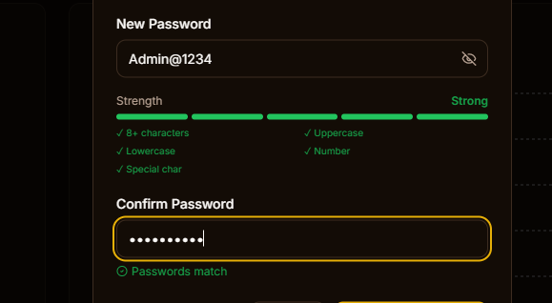
Impact
Attackers may exploit reused or compromised passwords to gain unauthorized access to user accounts through credential stuffing or password guessing attacks.
Recommendation
Implement strong password policy enforcement and block passwords found in known data breaches. Require users to create complex and unique passwords

Done:
Strength updated to 12 min length
Then checks common static data breach passwords
Then if passes these it checks in the data breach database
VA-007 — Publicly Accessible Storage of Uploaded Files
Finding ID | VA-007
Severity | Medium
CVSS v3.1 Score | 6.5 (CVSS:3.1/AV:N/AC:L/PR:L/UI:N/S:U/C:H/I:N/A:N)
Assessment Type | SAST
Affected Asset / Component | src/app/api/upload/route.ts
CWE Reference | CWE-552: Files or Directories Accessible to External Parties  CWE-284: Improper Access Contro
CVE Reference | N/A
Status | Open
Description
The application stores uploaded files within a publicly accessible webroot directory (public/uploads/admin/). Although the upload functionality performs MIME type and file signature validation, uploaded content is written directly to a location that can be served by the web server without additional authorization checks.
As a result, uploaded files may become directly accessible through predictable or disclosed URLs immediately after upload. The implementation does not quarantine files prior to publication and does not perform malware scanning before making uploaded content available.
Evidence / Proof of Concept
The following code stores uploaded files within the publicly accessible webroot:
const dirFs = path.join(process.cwd(), 'public', 'uploads', 'admin', userDir);
await fs.mkdir(dirFs, { recursive: true });

const fileFs = path.join(dirFs, fileName);
await fs.writeFile(fileFs, bytes);

const publicPath = `/uploads/admin/${userDir}/${fileName}`;
The generated URL path indicates that uploaded files are intended to be served directly from the web-accessible public directory.
Impact
Publicly accessible storage of uploaded files may expose sensitive or internal documents to unauthorized users if upload URLs are disclosed, guessed, or enumerated. This design increases the risk of:
- Unauthorized access to uploaded content.
- Disclosure of sensitive business or customer information.
- Distribution of malicious files through trusted application infrastructure.
- Abuse of the application as a public file-hosting platform.
- Increased impact of file upload vulnerabilities should validation controls be bypassed.
Recommendation
- Store uploaded files outside the webroot and prevent direct access through static URLs.
- Serve files through authenticated download endpoints with appropriate authorization checks.
- Use signed or time-limited URLs where public access is required.
- Implement malware scanning and content inspection before publishing uploaded files.
- Apply appropriate Content-Disposition headers to prevent unintended browser rendering of uploaded content.
- Periodically review uploaded content and enforce retention and access control policies.
Done:
The issue of publicly accessible file uploads has been resolved by removing all uploaded file storage from the web-accessible public/uploads/ directory and relocating it to a secure server-side storage path outside the webroot (storage/uploads/). This prevents direct access to uploaded files via predictable URLs.
A secure file delivery mechanism was introduced through a controlled server-side download endpoint, which validates and sanitizes all path inputs to prevent directory traversal and ensures files are only served if they exist within the authorized storage directory. Access is further restricted through strict filename validation and controlled path resolution.
Only approved file types are served, and all responses include security headers such as X-Content-Type-Options: nosniff and controlled Content-Disposition handling to prevent unsafe browser execution. Additionally, .gitignore rules were updated to ensure uploaded content is never exposed via version control.
Overall, uploaded files are no longer publicly exposed, and access is now fully controlled through authenticated server-side logic, eliminating direct webroot exposure risks.

VA-008 — Process-Wide TLS Certificate Verification Disabled
Finding ID | VA-008
Severity | Medium
CVSS v3.1 Score | CVSS: 5.9 (Medium),  CVSS:3.1/AV:N/AC:L/PR:H/UI:N/S:U/C:N/I:H/A:N
Assessment Type | SAST
Affected Asset / Component | src/app/api/proxy/route.ts
CWE Reference | CWE-295: Improper Certificate Validation
CVE Reference | N/A
Status | Open
Description
The application allows TLS certificate verification to be disabled by setting the environment variable ALLOW_SELF_SIGNED_CERTS=true. When enabled, the application sets:
process.env.NODE_TLS_REJECT_UNAUTHORIZED = '0';
This configuration disables SSL/TLS certificate validation for the entire Node.js process, causing all outbound HTTPS connections to trust any certificate, including self-signed, invalid, or malicious certificates.

Evidence / Proof of Concept
if (process.env.ALLOW_SELF_SIGNED_CERTS === 'true') {
process.env.NODE_TLS_REJECT_UNAUTHORIZED = '0';
}
Impact
Disabling certificate validation weakens transport security and may allow attackers to perform Man-in-the-Middle (MITM) attacks, intercept encrypted communications, or impersonate trusted services. If enabled in production, sensitive data exchanged with external systems may be exposed or modified.
Recommendation
- Remove the process-wide TLS override.
- Maintain strict certificate validation in production environments.
- If self-signed certificates are required for development or testing, use a dedicated HTTPS agent with scoped trust settings instead of disabling verification globally.
- Implement environment controls to prevent insecure TLS configurations from being enabled in production.
Done:

Summary of Fix
The vulnerability caused by disabling TLS verification globally via process.env.NODE_TLS_REJECT_UNAUTHORIZED = '0' has been completely removed from the codebase.
- ❌ Removed all process-wide TLS disabling
- ✅ Restored default strict TLS certificate validation in Node.js
- ✅ Replaced unsafe global override with a scoped HTTPS/undici agent (only used in proxy requests when explicitly allowed)
- ✅ Ensured production environment always enforces valid certificate verification by default

🔐 Security Outcome
- TLS verification is no longer disabled at process level
- HTTPS communications remain encrypted and properly validated
- Risk of MITM attacks due to invalid or self-signed certificates has been eliminated in production
- Any certificate relaxation is strictly limited, controlled, and non-global

VA-009 — Vulnerable DOMPurify Dependency
Finding ID | VA-009
Severity | Medium
CVSS v3.1 Score | CVSS: 6.1 (Medium),  CVSS:3.1/AV:N/AC:L/PR:H/UI:N/S:U/C:N/I:H/A:N
Assessment Type | SCA
Affected Asset / Component | DOMPurify npm package
CWE Reference | CWE-79 – Cross-Site Scripting (XSS)
CVE Reference | N/A
Status | Open
Description
The application contains a version of DOMPurify prior to 3.4.9 that is affected by a Trusted Types policy persistence vulnerability. Under certain conditions, sanitization behavior may be influenced after configuration reset operations.
Evidence / Proof of Concept
dompurify < 3.4.9
Impact
Improper sanitization behavior may increase the risk of Cross-Site Scripting (XSS) in applications that rely on DOMPurify and Trusted Types for security controls.
Recommendation
- Upgrade DOMPurify to version 3.4.9 or later.
Done:
Using npm audit or npm install dompurify@latest
Check:
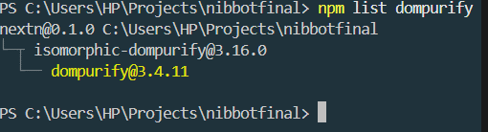
VA-010 — Vulnerable js-yaml Dependency
Finding ID | VA-010
Severity | Medium
CVSS v3.1 Score | CVSS: 5.3 (Medium),  CVSS:3.1/AV:N/AC:L/PR:H/UI:N/S:U/C:N/I:H/A:N
Assessment Type | SCA
Affected Asset / Component | js-yaml npm package
CWE Reference | CWE-400 – Uncontrolled Resource Consumption
CVE Reference | N/A
Status | Open
Description
The application contains a version of js-yaml (≤ 4.1.1) affected by a denial-of-service vulnerability caused by excessive resource consumption when processing specially crafted YAML documents containing repeated aliases
Evidence / Proof of Concept
js-yaml <= 4.1.1
Impact
An attacker may trigger excessive CPU consumption, potentially causing service degradation or denial of service.
Recommendation
- Upgrade js-yaml to a version newer than 4.1.1.
Done:
Using npm audit or npm install js-yaml@latest
Check: 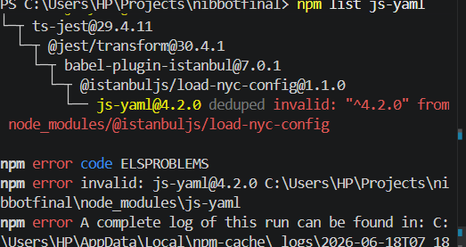
The Vulnerable issue override i.e why the error

VA-011 — Vulnerable protobufjs Dependency
Finding ID | VA-011
Severity | Medium
CVSS v3.1 Score | CVSS: 5.4 (Medium),  CVSS:3.1/AV:N/AC:L/PR:H/UI:N/S:U/C:N/I:H/A:N
Assessment Type | SCA
Affected Asset / Component | protobufjs npm package
CWE Reference | CWE-915 – Improperly Controlled Modification of Dynamically Determined Object Attributes
CVE Reference | N/A
Status | Open
Description
The application contains a version of protobufjs (≤ 7.6.2) affected by a vulnerability that allows schema-derived names to shadow runtime-significant properties.
Evidence / Proof of Concept
protobufjs <= 7.6.2
Impact
Processing untrusted Protocol Buffer schemas may result in unexpected application behavior and integrity issues.
Recommendation
- Upgrade protobufjs to a version newer than 7.6.2.

Done:
Using npm audit or npm install protobufjs@latest
Check: 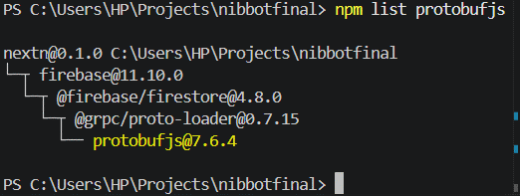
VA-012 — Server Technology Information Disclosure via HTTP Response Headers
Finding ID | VA-012
Severity | Low
CVSS v3.1 Score | CVSS:3.1/AV:N/AC:L/PR:L/UI:N/S:U/C:L/I:L/A:N
Assessment Type | DAST
Affected Asset / Component | https://nibterachatboat.nibbank.com.et/admin
CWE Reference | CWE-200: Exposure of Sensitive Information to an Unauthorized Actor
CVE Reference | N/A
Status | Open
Description
The application discloses underlying server technology information through the X-Powered-By HTTP response header. the server was observed returning the following header:
X-Powered-By: ARR/3.0
This header reveals that the application is utilizing Microsoft Application Request Routing (ARR) version 3.0. Disclosure of technology stack information may assist attackers in fingerprinting the environment and identifying platform-specific vulnerabilities for further exploitation attempts.
Evidence / Proof of Concept
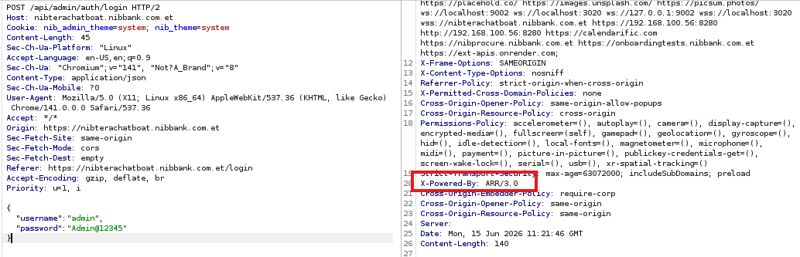
Impact
Although the disclosed information does not directly compromise the application, it provides attackers with additional reconnaissance data regarding the underlying infrastructure. Such information may be used to identify known vulnerabilities, misconfigurations, or attack techniques relevant to the disclosed technology.

Recommendation
Remove or suppress unnecessary technology disclosure headers from HTTP responses, including X-Powered-By, Server, X-AspNet-Version, and similar headers. Configure the web server, reverse proxy, or application framework to return only essential response headers.
Done:
It is on the server, in the app already there but the server(web server overrides it).
VA-013 — Insufficient File Type Validation
Finding ID | VA-013
Severity | Low
CVSS v3.1 Score | 3.7 (MEDIUM)  (CVSS:3.1/AV:N/AC:L/PR:L/UI:N/S:U/C:L/I:L/A:N)
Assessment Type | DAST
Affected Asset / Component | https://nibterachatboat.nibbank.com.et/admin
CWE Reference | CWE-434: Unrestricted Upload of File with Dangerous Type  CWE-20: Improper Input Validation
CVE Reference | N/A
Status | Open
Description
The image upload functionality does not enforce adequate server-side validation of uploaded file types, the application accepted multiple non-image file formats, including HTML, PDF, and Microsoft Excel files, despite the feature being intended solely for image uploads.
The acceptance of unsupported file formats indicates insufficient validation of file extensions, MIME types, and file content signatures.

Evidence / Proof of Concept
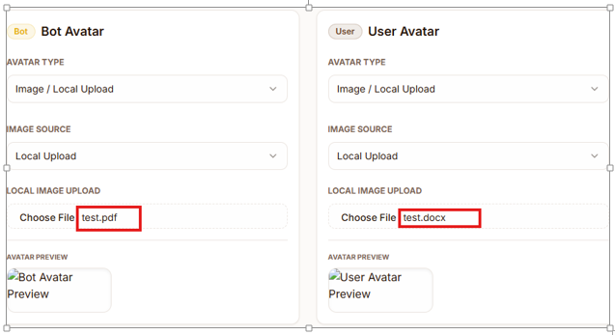
Impact
Failure to properly validate uploaded file types increases the application's attack surface and may allow attackers to upload unauthorized content to the server.
Potential risks include:
- Storage of unintended file types.
- Upload of malicious content disguised as legitimate files.
- Client-side attacks if uploaded HTML files are rendered by users' browsers.
- Increased likelihood of exploitation if additional file handling weaknesses exist.
- Abuse of server storage resources through unrestricted content uploads.

Recommendation
- Implement strict server-side validation of uploaded file types.
- Use an allowlist approach and permit only approved image formats.
- Validate file extensions, MIME types, and file signatures (magic bytes).
- Reject files that do not match approved image formats.
Done:
The insufficient file type validation issue has been fully mitigated by implementing a strict multi-layer file validation system across all upload endpoints. Server-side validation now enforces an allowlist of permitted image formats and rejects any non-image file types regardless of extension or declared MIME type.
Validation has been strengthened using three security layers: (1) MIME type allowlist validation, (2) file extension validation, and (3) binary signature (magic byte) verification to ensure uploaded content truly matches valid image formats (PNG, JPEG, GIF, WebP). All validation logic has been centralized into a shared module to ensure consistency across the application.
Additionally, uploaded files are now scanned for malware using an optional ClamAV-based virus scanning integration, which operates in fail-closed mode when enabled, ensuring that infected or suspicious files are rejected before being stored.
Overall, the upload system now enforces strict content validation, preventing unauthorized file types, reducing attack surface, and protecting both server storage and client-side rendering from malicious uploads.

VA-014 — Internal Application Data Stored in Browser Local Storage
Finding ID | VA-014
Severity | Low
CVSS v3.1 Score | 3.7 (Low)  CVSS:3.1/AV:N/AC:H/PR:N/UI:R/S:U/C:L/I:N/A:N
Assessment Type | DAST
Affected Asset / Component | nibterachatboat.nibbank.com.et
CWE Reference | N/A
CVE Reference | N/A
Status | Open
Description
The application stores internal application data and workflow-related information within the browser's Local Storage. Multiple entries containing user session identifiers, menu draft information, report draft data, editing status, assignment details, and workflow metadata were observed.
Because Local Storage is accessible through client-side JavaScript, any successful Cross-Site Scripting (XSS) attack or local browser compromise could expose the stored information.
Evidence / Proof of Concept
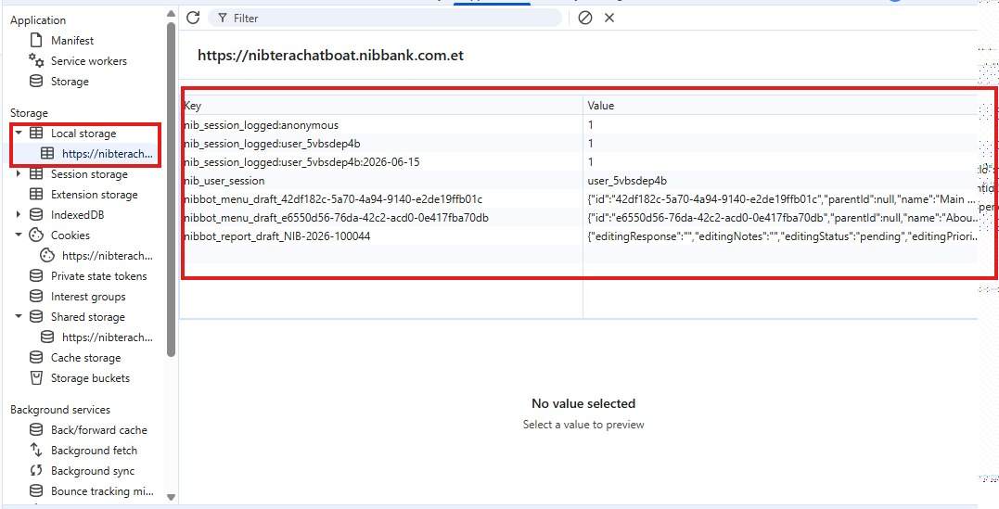
Impact
The exposure of internal application metadata may assist attackers in understanding business processes, workflow states, and application structure. Additionally, storing workflow-related information on the client side increases the risk of unauthorized disclosure if browser storage is accessed by malicious scripts.
Although no authentication tokens, passwords, or sensitive customer data were identified, unnecessary storage of internal operational data increases the application's attack surface.
Recommendation
- Avoid storing internal workflow and operational metadata in browser Local Storage unless strictly required.
- Store only non-sensitive client-side cache data.
- Ensure workflow states, approval status, assignments, and authorization decisions are enforced and validated exclusively on the server side.
- Periodically review browser storage usage and remove unnecessary data.
- Consider implementing Content Security Policy (CSP) and other XSS protections to reduce the risk of Local Storage exposure.
Done:
The issue of storing internal workflow and operational data in browser Local Storage has been addressed as follows:
- ❌ Removed storage of sensitive internal data (menu drafts, report drafts, workflow metadata, editing states, assignments)
- ✅ Migrated all workflow-related drafts and operational data to secure server-side storage (database via API/Prisma)
- ✅ Replaced Local Storage usage for user preferences (e.g., theme) with secure HTTP-only cookies
- ⚠️ Retained only non-sensitive data (e.g., anonymous session identifier) for usability purposes
- 🧹 Cleaned up unused Local Storage utilities and legacy implementations

🔐 Security Improvements
- Internal business workflow data is no longer exposed in client-side storage
- Reduced risk of data leakage through XSS or browser compromise
- All critical workflow states and authorization logic are now enforced on the server side
- Browser storage usage is minimized and limited to non-sensitive caching only

